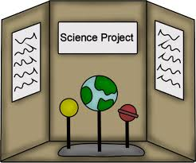
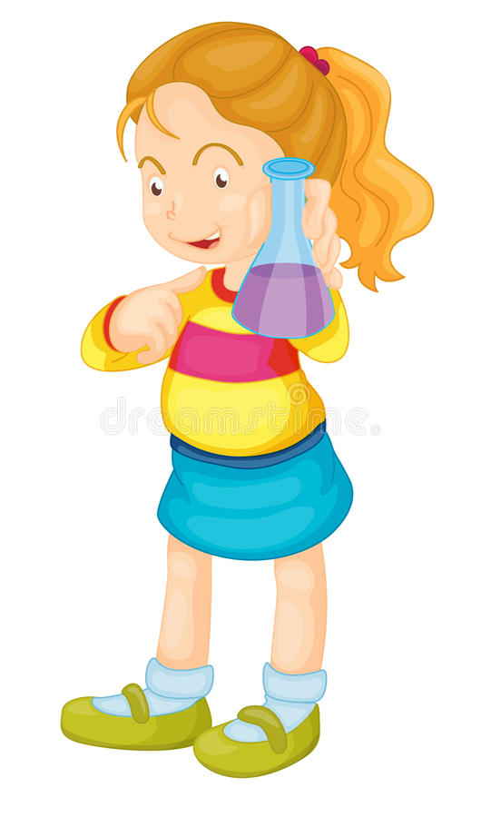
Science Fair 2018
Pacing Guide

Scientist:
Name

Science Fair Pacing Guide Calendar

March 2018
Monday | Tuesday | Wednesday | Thursday | Friday
 |  |  | 1 | 2
5  Project directions sent home. | 6 | 7 | 8 | 9
12 | 13 | 14 | 15  Begin learning about your topic. Visit the library and do some research. Use the Science Fair Handbook for resources. Choose your topic/question. | 16
19 | 20 | 21 | 22  Decide how to set up your experiment. Write your research question and hypothesis. Write the materials and procedure for your experiment. Read it to your family and make sure you have listed every step. | 23
26 | 27 | 28  Conduct the experiment and record data. Analyze your data. Include charts, graphs, tables, averages, etc. Remember to take photos or draw pictures to document your experiment if appropriate. | 29 | 30

April 2018
Monday | Tuesday | Wednesday | Thursday | Friday
2 | 3 | 4 | 5  Write your conclusion. Was your hypothesis correct? Tell what factors may have influenced the outcome and what you would change next time.  Write what you would do next time. | 6
9 | 10  Make your display board | 11 | 12 | 13
16  SCIENCE FAIR!  Judging  Bring project to school. | 17  SCIENCE FAIR! Visit Exhibits  Pick up project after STEM Family Night. | 18  Pick up project from school before noon.

Check out the Science Fair 2018 Handbook for other valuable information.
Rough Draft
Science Fair Pacing for ___________________________________

Science Fair Experiment Question: __________________________________________________________________
__________________________________________________________________
__________________________________________________________________
__________________________________________________________________
__________________________________________________________________
__________________________________________________________________
__________________________________________________________________
__________________________________________________________________
__________________________________________________________________
__________________________________________________________________

Hypothesis: ________________________________________________________
__________________________________________________________________
__________________________________________________________________
__________________________________________________________________
__________________________________________________________________
__________________________________________________________________
__________________________________________________________________
__________________________________________________________________
__________________________________________________________________
__________________________________________________________________
__________________________________________________________________

Rough Draft
Science Fair Pacing for ___________________________________
Materials List:

__________________________________________________________________
__________________________________________________________________
__________________________________________________________________
__________________________________________________________________
__________________________________________________________________

__________________________________________________________________
__________________________________________________________________
__________________________________________________________________
__________________________________________________________________
__________________________________________________________________

Procedure:
__________________________________________________________________
__________________________________________________________________
__________________________________________________________________
__________________________________________________________________
__________________________________________________________________
__________________________________________________________________
__________________________________________________________________
__________________________________________________________________
__________________________________________________________________

__________________________________________________________________

_________________________________________________________________

__________________________________________________________________

__________________________________________________________________
Rough Draft
Science Fair Pacing for ___________________________________
Data Collection:
Make your charts to display your data here.

Rough Draft
Science Fair Pacing for ___________________________________

Data Collection:
Make your charts to display your data here.

Science Fair Homework for ___________________________________
Rough Draft
Graph or Visual of Results:

Science Fair Pacing for ___________________________________
Rough Draft
Conclusion:
__________________________________________________________________
__________________________________________________________________
__________________________________________________________________
__________________________________________________________________
__________________________________________________________________
__________________________________________________________________
__________________________________________________________________
__________________________________________________________________
__________________________________________________________________
__________________________________________________________________
__________________________________________________________________
__________________________________________________________________
__________________________________________________________________
__________________________________________________________________
__________________________________________________________________

Next Time:
__________________________________________________________________
__________________________________________________________________
__________________________________________________________________
__________________________________________________________________
__________________________________________________________________
__________________________________________________________________
__________________________________________________________________

