MCS Science Fair 2018

April 16th – 17th

Dear Parents,
As you know, science, technology and engineering are basic skills needed for students today. MCS students will have to make future decisions based on their understanding of emerging science skills. Science fairs involve students in the practices of science, requiring them to apply those skills to a topic of interest to them. Doing science is key to understanding science.

Our school is holding a science fair on Monday, April 16-17, 2018 and all students in
grades 1-5 are invited to participate. 1st, 2nd, and 3rd place ribbons will be given at each grade level. 1st place winners will also receive memberships to the St. Louis Science Center, Zoo, MO Botanical Gardens, Butterfly House, or the Magic House.

Hands-on scientific investigations are the focus at our particular fair. Over a 5-week period, your child will design a project that uses scientific methods to solve a problem. The sky’s the limit!
Please note that the work will be done at home. Students will need to be given project guidelines and timelines at home. However, most of the work will be self-directed. Parents are encouraged to offer emotional support and reminders, but to allow children to do the projects by themselves.
We encourage you to visit the school’s website at https://maryvillechristian.org/ (Elementary-Parent Resources-Science Fair) for the Science Fair Handbook, Pacing Guide, and other valuable information and resources.
MCS Science Fair 2018 will be held in conjunction with STEM Family Night. The fair judging will take place on Monday, April 16th. STEM Family Night will be on Tuesday, April 17th. We invite you to browse the fair exhibits Monday (16th) afternoon until 5:00 p.m. and Tuesday during STEM Family Night from 6:00-8:00 p.m.
Please fill out and sign the attached registration form giving permission for your child to participate in the MCS Science Fair 2018 and return it to school in an envelope labeled, Science Fair, Mrs. Kerr. When the signed form is received, your child will be given a copy of the handbook that will help them prepare their project.
Don’t hesitate to call or email me with any questions. Thank you very much in advance for your support!
Sincerely,
Mrs. Kerr
STEM/Science Teacher
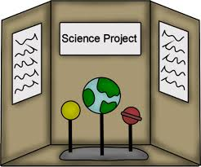
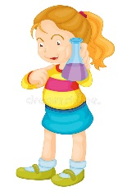
MCS Science Fair 2018
April 16th-17th

The Science Fair will be held April 16th-17th. If you are interested in participating in the fair, please have your parents sign below and return in an envelope labeled Science Fair, Mrs. Kerr by Tuesday, February 27th.

Team Entry (2 students) – Please Print
Participants’ Names: ______________________ _________________________

Grade Level: ____________ Teachers’ Names ___________________________

Parent’s Signature: __________________________________________________

Parent’s Phone: ____________________________________________________

Parent’s Email: _____________________________________________________

Individual Entry (1 student) – Please Print

Participant’s Name: _________________________________________________

Grade Level: ____________ Teacher’s Name _________________________

Parent’s Signature: __________________________________________________

Parent’s Phone: ____________________________________________________

Parent’s Email: _____________________________________________________

